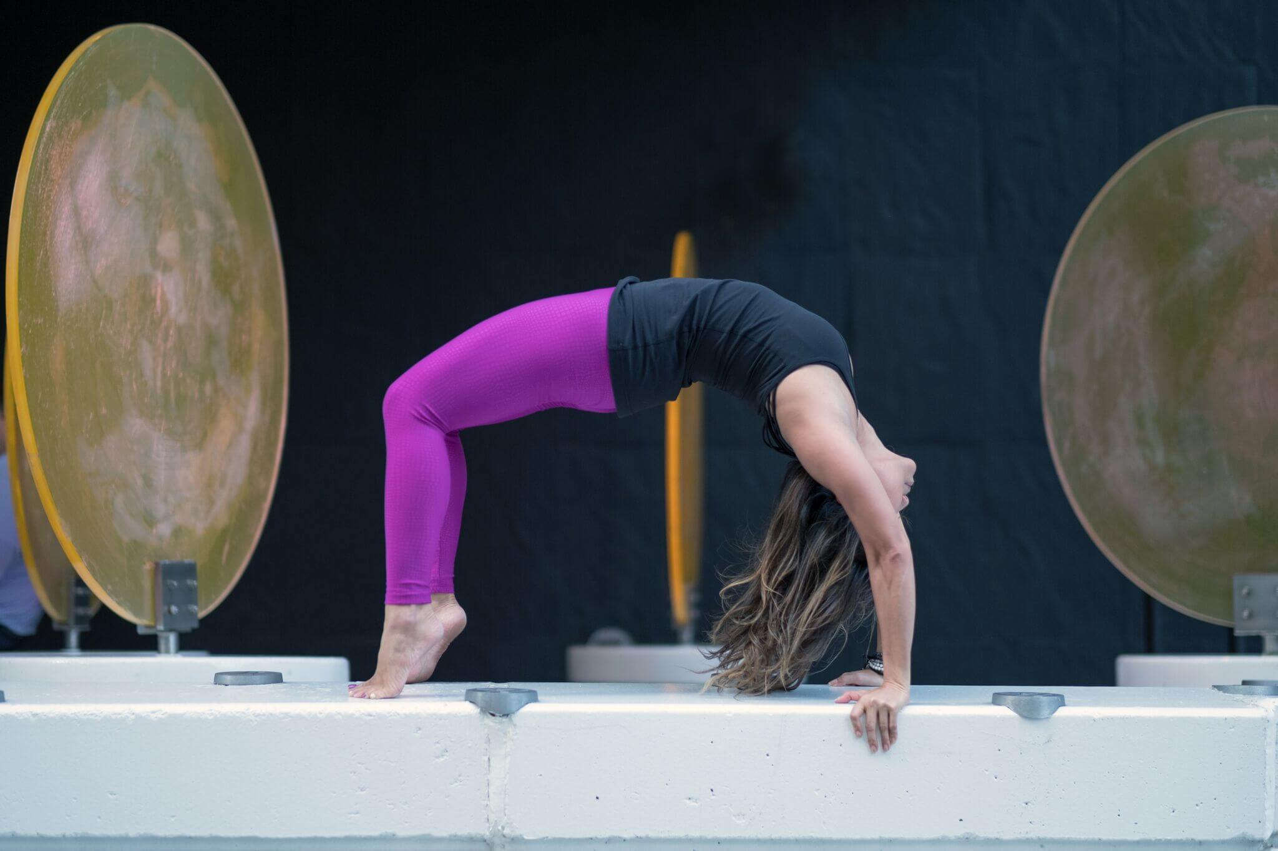

20th Jan 2019 - 28th Feb 2019

2019 2nd Edition

40 Days Daily Logs

Addendum to the “40 days to Personal Revolution 2019” workbook

WEEK 1  presence | MONDAY | TUESDAY | WEDNESDAY | THURSDAY | FRIDAY | SATURDAY | SUNDAY
MEDITATION

BREAKFAST

SNACK

LUNCH

SNACK

DINNER

YOGA PRACTICE

MEDITATION

JOURNALLING

I CAN DO THIS! This week, I wAnt to feel/be/have ______________________________

I HAVE THE COURAGE! This week, I wAnt to feel/be/have ______________________________
WEEK 2  Vitality | MONDAY | TUESDAY | WEDNESDAY | THURSDAY | FRIDAY | SATURDAY | SUNDAY
MEDITATION

BREAKFAST

SNACK

LUNCH

SNACK

DINNER

YOGA PRACTICE
MEDITATION

JOURNALLING

I FORGIVE MYSELF! This week, I wAnt to feel/be/have _________________________________
WEEK 3  equanimity | MONDAY | TUESDAY | WEDNESDAY | THURSDAY | FRIDAY | SATURDAY | SUNDAY
MEDITATION

BREAKFAST

SNACK

LUNCH

SNACK

DINNER

YOGA PRACTICE

MEDITATION

JOURNALLING

I DESERVE TO BE HAPPY! This week, I wAnt to feel/be/have ___________________________
WEEK 4  restoration | MONDAY | TUESDAY | WEDNESDAY | THURSDAY | FRIDAY | SATURDAY | SUNDAY
MEDITATION
BREAKFAST

SNACK

LUNCH

SNACK

DINNER

YOGA PRACTICE
MEDITATION
JOURNALLING

I AM SLAYING IT! This week, I wAnt to feel/be/have _____________________________________
WEEK 5  centering | MONDAY | TUESDAY | WEDNESDAY | THURSDAY | FRIDAY | SATURDAY | SUNDAY
MEDITATION
BREAKFAST

SNACK

LUNCH

SNACK

DINNER

YOGA PRACTICE
MEDITATION
JOURNALLING

WEEK 6  triumph | MONDAY | TUESDAY | WEDNESDAY | THURSDAY | FRIDAY | SATURDAY | SUNDAY
MEDITATION
BREAKFAST

SNACK

LUNCH

SNACK

DINNER

YOGA PRACTICE
MEDITATION
JOURNALLING
I GOT THIS! This week, I wAnt to feel/be/have _____________________________________

